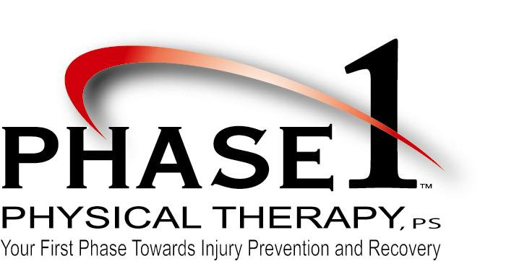
6066 Highway 291
Nine Mile Falls, WA 99026
509-465-5663
Fax 509-467-8663
Phase 1 Physical Therapy, PS STEM Scholarship

Phase 1 Physical Therapy, PS is awarding one $500 scholarship to a graduating senior of Lakeside High School (LHS) who is interested in pursuing a science, technology, engineering or mathematics (STEM) related career through post-secondary education.

Phase 1 Physical Therapy, PS has served the Nine Mile Falls community since its inception in 2003. With a passion for exceptional patient care and commitment to service to the greater community at large, the providers and staff at Phase 1 Physical Therapy, PS are pleased to be able to support students who express an interest in helping others through a career in the STEM fields.

Requirements:
- Lakeside High School senior
- Admitted or pending admission to a university or community college for the upcoming school year
- Planning on pursuing a degree in a STEM field
- Completed application
- Letter of recommendation from a teacher, counselor or school administrator
- Statement of completed community service

Completed scholarship applications are submitted to Brent Osborn, Principal of LHS, by2:00 pm on Wednesday, May 4th. The recipient of the Phase 1 Physical Therapy, PS STEM Scholarship will be notified at the Academic Awards Night at LHS.
APPLICATION FORM

Name:
Address:
Phone(cell):
Email:
Intended Career or Intended College Major:

